**ACTIVITY 5**

**NAME : Abinaya COURSE: MOBILE COMPUTING**

**REG NO : 192421208 COURSE CODE: ITA0302**

5. Design a wireframe for a mobile application that incorporates localization features using

Figma.

**Aim: -**

To design a wireframe using Figma for a mobile application that incorporates localization

features

**Procedure: -**

1. open Figma

2. Create a new file

3. Select the Frames

4. Design Visual Elements

5. Make it Interactive

6. Add icons on the Frame

7. Incorporate Multimedia

8. Storyboard Animation

9. Review and edit the Prototype

10. Save and Share

**Design:-**

 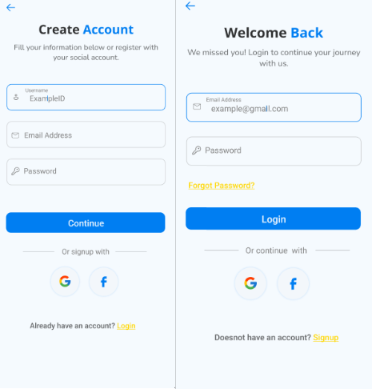

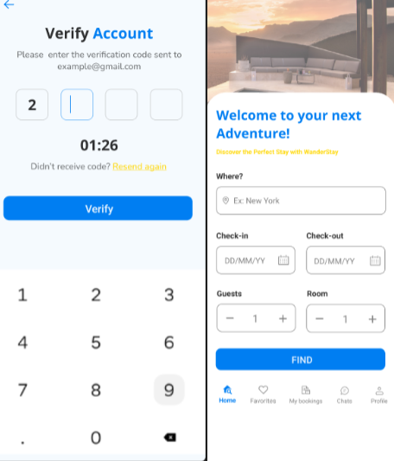 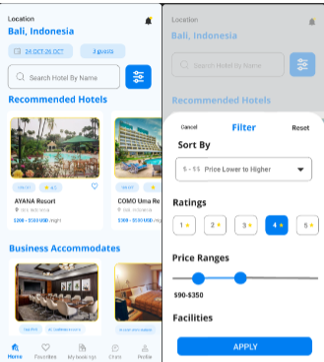 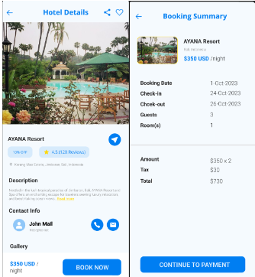

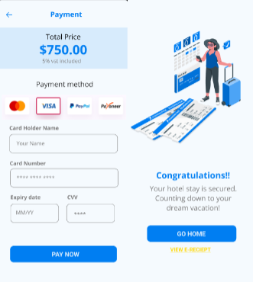

**Prototype:**

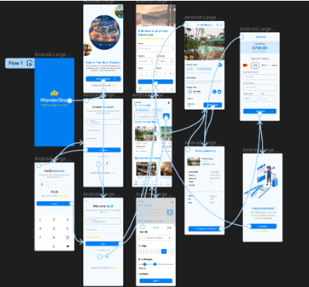

**Result: -**

Hence the wireframe for a mobile application that incorporates localization features using Figma

is created and executed successfully